Query ZODATA_OR_Q1_CDC_CDP_AWS_V2

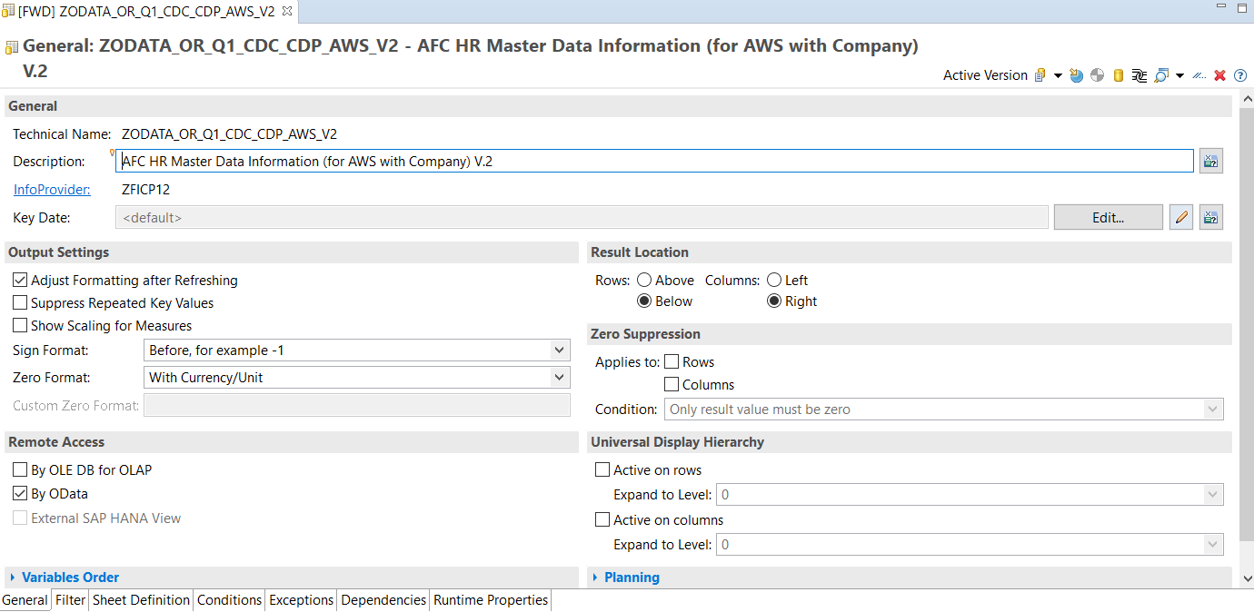

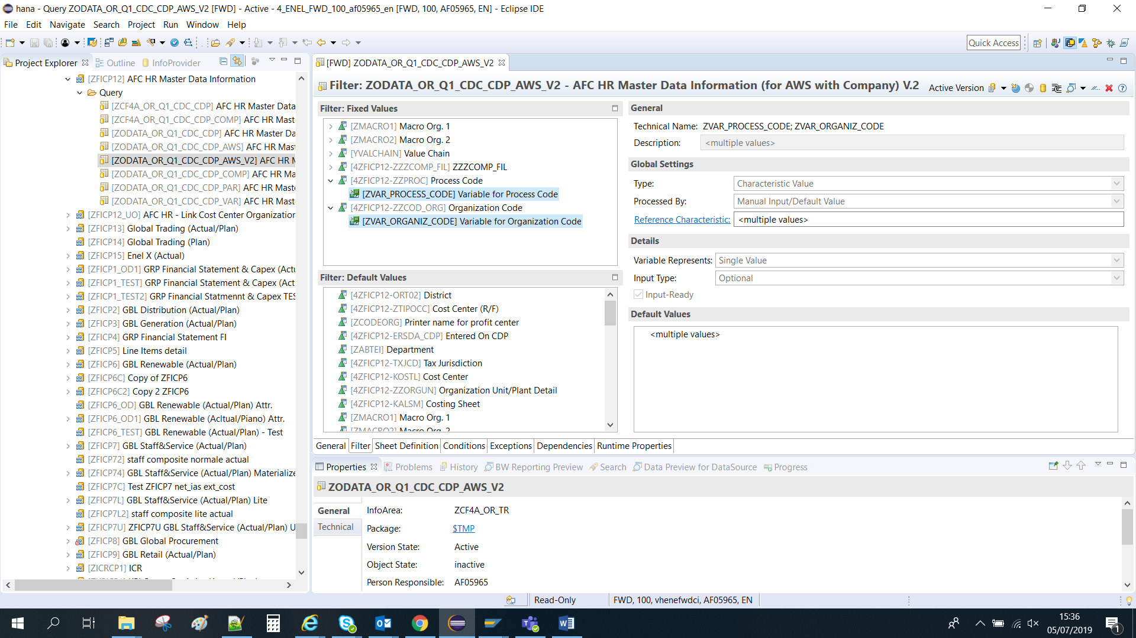

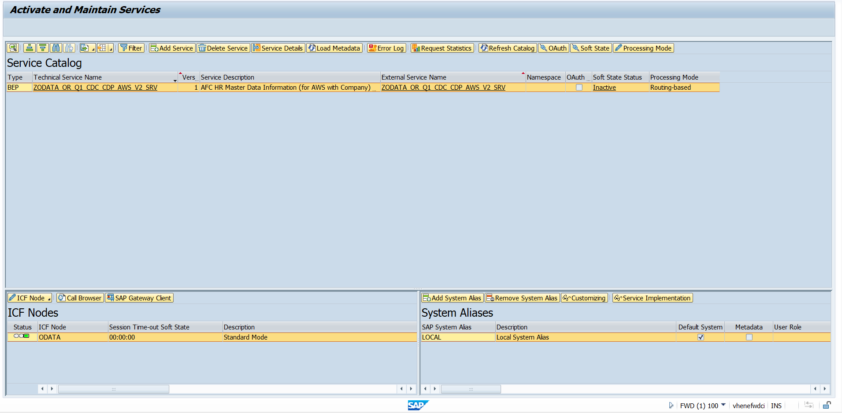

Test quadratura tra i due link in FWD:
Estrazione completa:
Link Old:
https://fwdci.hec.enelint.global:44300/sap/opu/odata/sap/ZODATA_OR_Q1_CDC_CDP_AWS_SRV/ZODATA_OR_Q1_CDC_CDP_AWS(ZVAR_MACRO_ORG1='BREN',ZVAR_MACRO_ORG2='ACTSE99',ZVAR_VCS='VCS0000 ',ZVAR_COMPANY_FILTER='')/Results/?saml2=disabled&$format=json
Link New:
https://fwdci.hec.enelint.global:44300/sap/opu/odata/sap/ZODATA_OR_Q1_CDC_CDP_AWS_V2_SRV/ZODATA_OR_Q1_CDC_CDP_AWS_V2(ZVAR_MACRO_ORG1='BREN',ZVAR_MACRO_ORG2='ACTSE99',ZVAR_VCS='VCS0000',ZVAR_COMPANY_FILTER='',ZVAR_PROCESS_CODE='',ZVAR_ORGANIZ_CODE='')/Results/?saml2=disabled&$format=json

